Draw your own hay bale art

What can you create from your own hay bale? If you need more hay bales, draw them in.

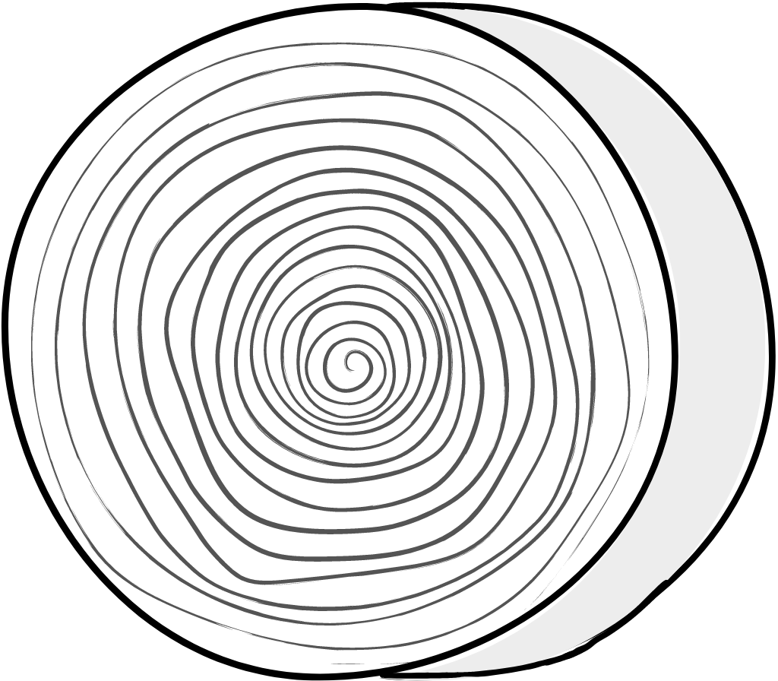

Make a season wheel

Write the names of the seasons around the outside of the wheel and fill the quarters with images of the season.

